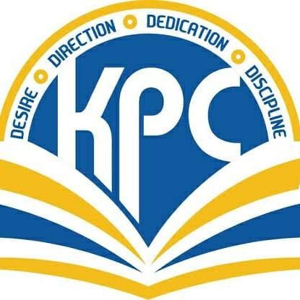
K.P.C. PUBLIC SCHOOL, KHARGHAR
Term I 2022-2023
STD: VI MARKS: 40
SUB: SCIENCE TIME: 2 HRS

Q1: FILL IN THE BLANKS: (6M)
- Living things become more ______ as they grow.
- In North America, grasslands are called ______.
- Heartbeat is a _____ motion.
- The purest form of water is ______.
- _______ is used to make the filament of a household bulb.
- Honeybee makes honey from ______.

Q2: MATCH THE PAIRS: (5M)
COLUMN ‘A’ | COLUMN ‘B’
- Unicellular organisms | - Movement of charges
- SI units | - Saline
- Seawater | - Amoeba
- Electric current | - Scurvy
- Citrus fruits | - France, 1971

Q3: Distinguish between: (6M)
- Vegetable fat and Animal fat
- Oscillatory motion and Periodic motion

Q4: Odd man out with reason: (3M)
- Filament, Glass chamber, Holder, Gold
- Thread, Fist, Foot, Stones.
- Evaporation, Condensation, Salination, Precipitation.

Q5: Answer in Short: (5M)
- What is the direction of current flow through a battery?
- Why is copper used for household wiring?
- Define transpiration.
- List the different sources of water.
- Which part of India popularly uses groundnut oil for cooking?

Q6: True or False: (5M)
- Synthetic fibres have more absorption capacity than natural fibres
- Animals that eat only animals are called carnivores.
- The motion of potter’s wheel is vibratory motion.
- Rainwater harvesting is the technique to collect and store rain water.
- Electric batteries have one terminal.

Q7: Draw and label the diagram of torch. (4M)

Q8: Long answer question: [Any 2] (6M)
- Explain briefly translatory motion.
- What is a flood? What is its effect?
- List some uses of electricity.

